
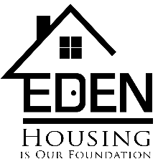
LANDLORD ASSISTANCE REQUEST FORM
(to be completed by Landlord)
Tab and type to complete the form

Tenant Name:
Address, unit #
City, State, Zip
Amount of Security Deposit: | $
Monthly Rent Amount: | $
Tenant Portion of Rent  (if eligible for subsidy): | $
Total Funds Requested: | $
Reason for Request:
Owner’s Name
(1099 recipient):
* Owner’s name must be the name of person, company, etc. who the check is made out to and who is responsible for the IRS reporting
Owner’s Tax I.D. or Social Security # for IRS reporting:
*Must match the 1099 recipient
Owner’s Address:
Owner’s Phone Number:
Owner’s email address:
Please check all that apply:
By accepting these funds, I agree to not move forward with an eviction for this household.
By accepting these funds, I agree to rent this property to future EDEN tenants.
By accepting these funds, I agree to rent this property to future EDEN tenants who have been involved in the criminal justice system.
Date and Owner’s Signature
This form must be accompanied by a completed W-9 form and Lease Agreement.
See www.EDENcle.org/owners for assistance with completing the W-9 form.
HOUSING RESOURCE & DEVELOPMENT AGENCY
7812 Madison Avenue, Cleveland, OH 44102 | (216)961-9690 | FAX (216)651-4066

Shelter Plus Care FAX (216) 651-6692 | www.EDENcle.org | EDENinfo@EDENcle.org
TDD/TTY: 1-800-545-1833, ext. 873
A Contract Agency of the Alcohol, Drug and Mental Health Services Board of Cuyahoga County

